A Parent’s Guide to the Year 1 Phonics Screening Check
What do we mean by PHONICS?
Phonics is one of a range of tools that children use to learn to read and write.
In order to read and write, children need to:
learn their letter sounds
learn to form their letters
learn to blend sounds together for reading
learn to identify the sounds in words for writing
learn to read and spell the tricky high frequency words
As well as learning the sounds made by individual letters, your child learns how letters combine to make new sounds such as sh and oi.
What is the Phonics Screening Check?
The Government have introduced a phonics screening check that is compulsory for all primary schools with Year 1 children. It will take place during June.
The check will form part of the assessment, made by your child’s teacher, of how your child is progressing with the important skills of reading and writing.
Your child will sit with a teacher he/she knows well and be asked to read 40 words aloud.
Some of these words will be familiar to your child and some will be ‘nonsense words’.
All the words will be words that can be read by ‘sounding out’.
The ‘nonsense words’ are included as these will not be familiar to any of the children and therefore no one has an unfair advantage.
Before the end of this term, you will be informed by the school about how your child has performed in the screening check and how he/she is progressing with phonics.
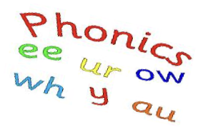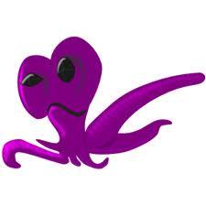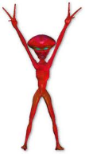
vap climp chilter
How can I help my child?
There are a number of things that parents can do to support early reading development:
♣ Let your child see you enjoy reading yourself. They are influenced by you and what you do!
♣ Immerse your child in a love of reading
♣ Make time for your child to read their school book to you
♣ With all books, encourage your child to ‘sound out’ unfamiliar words and then blend from left to right rather than looking at pictures to guess
There are many phonic games for children to access on the computer.
www.phonicsplay.co.uk
www.lettersandsounds.com

