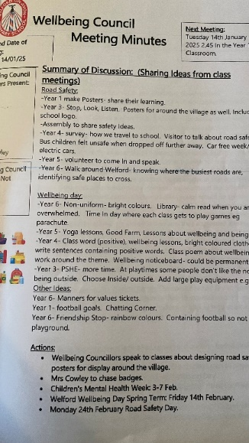
Welford On Avon Primary School Wellbeing Council Application for Picture News Award
How have we influenced our community?
Developing ourselves as a new and influential body in the school community. We have regular Council meetings and the minutes are shared with staff, pupils and on the school website. Representatives then lead meetings in their class to gain feedback and ideas from all children.
Initiatives we have been responsible for:
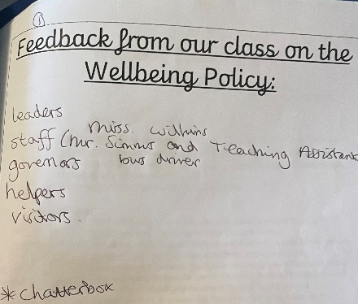
Contributing to the Welford On Avon Primary School Mental Health and Wellbeing Policy: Children shared the proposed policy in class and gathered feedback, their ideas were used to adapt and improve the policy. The children were very clear that they wanted all members of the school community identified in the policy, including the caretaker and office staff.
Promoting Children’s Mental Health Week: Wellbeing Council led an assembly for the whole school to introduce

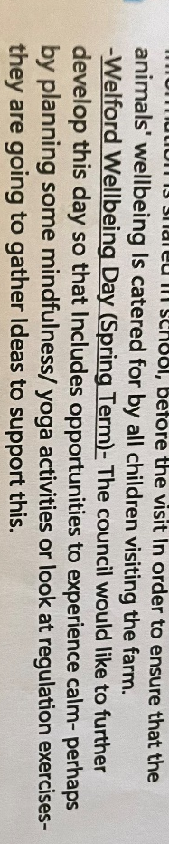
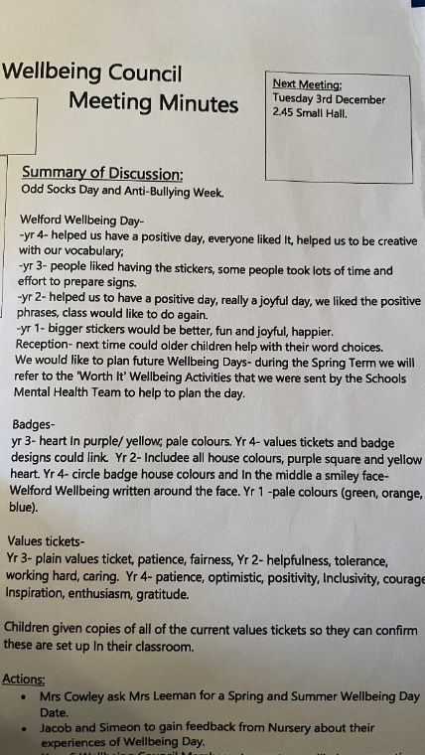
Establishing Termly Wellbeing Days: Wellbeing day in the Autumn Term- which consisted of each child bringing a positive word to share. The Council then spoke to their classes and reflected on the day. They decided that they would like to have a day which has more impact, recorded in meeting minutes.
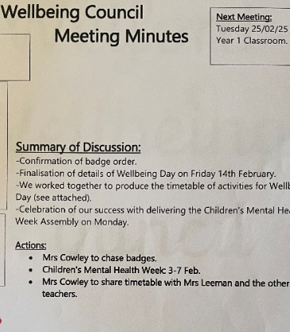
The Wellbeing Council then used their meeting times to plan the whole day in the Spring Term so that every class had a chance to access Wellbeing Related activities. Feedback from the school community (staff and pupils) was extremely positive. As is show in our meeting minutes.
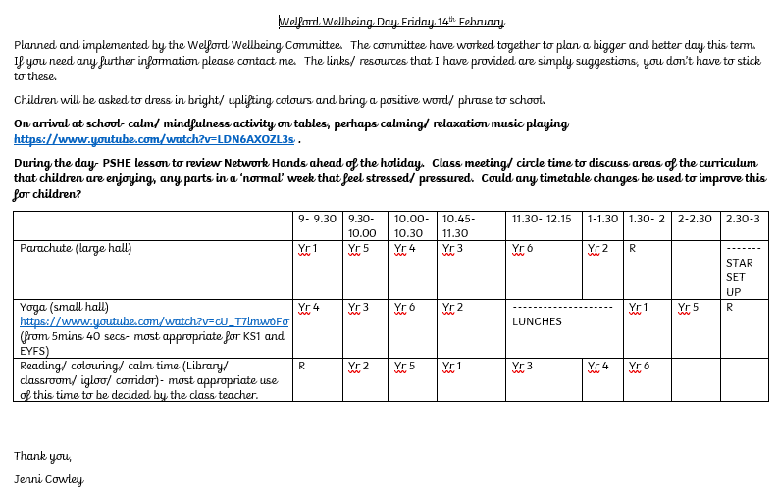

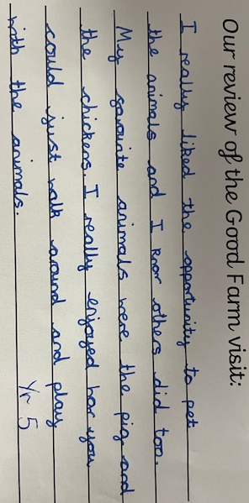
Good Farm Day Visits: (Autumn Term) Members of the council used their family links to organise a complimentary visit from a farm (sheep, chickens, horse, pig, goat) all brought to school and all children from school got to visit and complete activities. The feedback from the children, and staff, was so positive that they have been able to use school funds to arrange a repeat visit during the Summer Term.
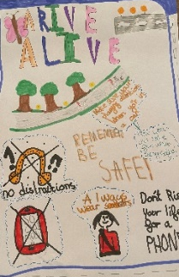
Promoting Road Safety:
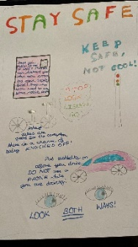
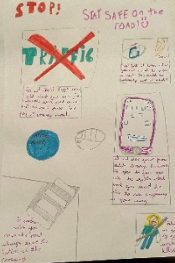
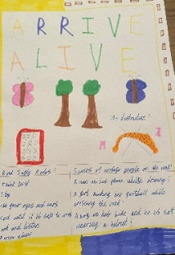
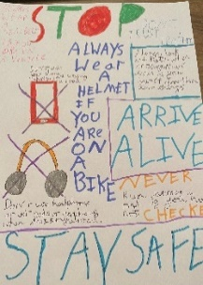
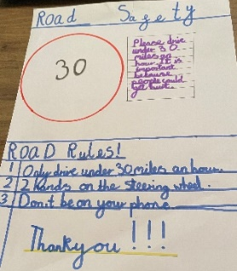
This project has influenced both people within and beyond our school community as our posters have been displayed in the village church, noticeboard on Headland Road and Shared in the Welford Matters local magazine.
Barriers that we have had to be overcome… helping staff to identify time alongside the curriculum to include these activities.

